Node JS File System

Git url

<https://github.com/shrutimannikeri/nodejs-filesystem>

render url

<https://filesystem-1dvy.onrender.com/>

createfile api:

<https://filesystem-1dvy.onrender.com/createfiles>

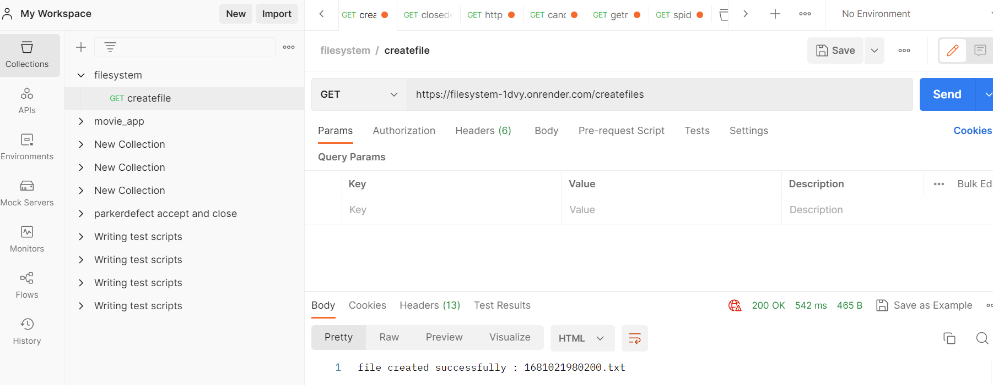

read file:

<https://filesystem-1dvy.onrender.com/read-directory>

